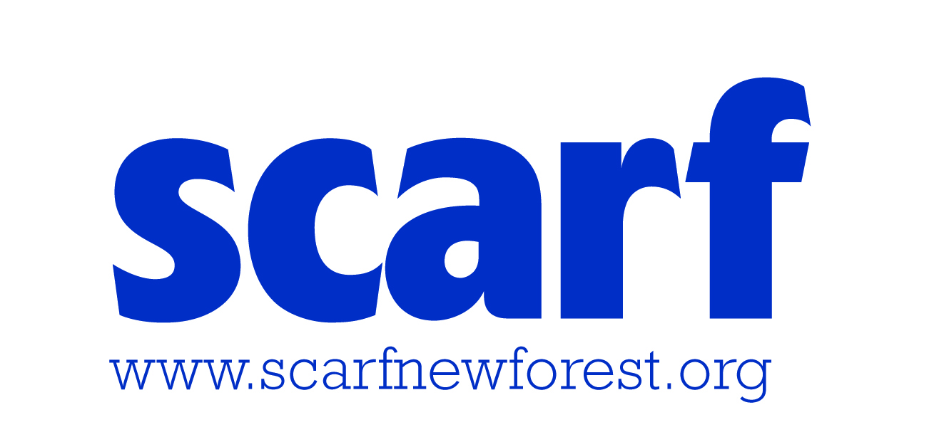
Scarf Personal Passport - All About Me!

The Basics!
My name is: | My date of birth is:
Today’s date: | My age:
My Mum/Dad/Carer’s Name(s):

My additional needs/diagnosis:

How I like to communicate
How I like to communicate (eg: verbally, sign language, Makaton, non-verbal, communication aids, other):

If I find it difficult to communicate, I often use these behaviours to tell you something:

How I like you to communicate with me (eg: speech, speaking slowly, not too many instructions at once, signing, objects of reference, etc.)

Likes and Dislikes
The things I like doing are (include any special interests):

The things I don’t like are (eg. loud music, shouting, sticky objects, close contact with other people, too much attention at once, being quiet, staying still, etc.)

If I don’t want to do something I will tell you by:

If I become angry/irritated/frustrated I want you to (include how I may behave/the signs I’m feeling like this):

Please let us know if there any behaviour plans in place that we can use to help defuse a difficult situation or wording used at home that you respond to positively:

Sensory Needs
These are the things I struggle to tolerate (eg: noisy places or certain noises, crowded places, smells, particular foods, fabrics, textures, etc)

If it gets too much for me, this is what you can do to help:

Physical Skills
This is how I move around (including walking, running, climbing stairs, coping with uneven surfaces, etc.):

This is how you can help me move around and the equipment that I use:

(at present Scarf staff are not trained to assist with lifting – please contact us if this is an issue)
How I like to socialise
I find making new friends easy/not so easy:

I prefer to be with friends/own company/with adults or helpers:

I like working in a group/prefer my own space:

Things you can do to help me with socialising/making friends:

Personal Care and Hygiene
This is how I manage my personal care (we understand this is very personal, but please tell us if you can manage on your own/need reminding to use the toilet/need reminding to wash your hands/ any signs that show you may need the toilet, etc.)

Eating and Drinking
These are the things I don’t like eating or can’t eat (include any allergies or food intolerances):

(Scarf sometimes provides snacks at clubs, so it’s helpful to know what you can’t have!)
This is how you can help me when I’m eating and drinking:

Thank you for filling out the form. Please let us know if anything changes so that we can update the form. We will ask you to update this form annually.

All the above information will be held for the period that you are a member of Scarf and will only be accessed by the Supervisor leading the activity that you attend, and the support workers working with you.

