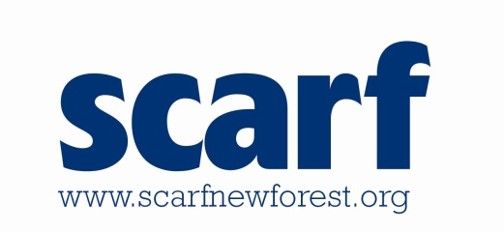
Scarf Medical Questionnaire and Consent Form

The information on this form will be held for information purposes, to help us to ensure that we are meeting the needs of your child/young person. The information will be retained securely and only shared with Scarf employees or committee members working with your child. This form should be completed annually, but please notify us if there are any changes regarding your child as soon as possible.

Name of Child/Young Person:
Name of Child/Young Person:

Name child/young person prefers to be called: |  |  | Sex (please circle/delete):  Male Female
Date of Birth: |  |  | Current age:
Home Address:

Postcode:
Brief description of the child/young person’s special needs/disability:

(more details will be covered in the Scarf Personal Passport form)
Parent or Carers Name/s:

Home phone Number: |  | Mobile phone number/s:
Work phone number: |  | Contact email:
Second contact name (in case of emergencies): |  | Relationship to child:
Home number: |  | Mobile number:
Name and address of Doctor:

Doctor’s telephone number:

School/College that child/young person attends:

Medical Information

Has your child/young person had any of the following?
Asthma or bronchitis | YES/NO | Allergies to any known medication | YES/NO
Heart condition | YES/NO | Any other allergies, eg. material, food, bee stings, plasters | YES/NO
Fits, fainting or blackouts | YES/NO | Other illness or disabilities | YES/NO
Severe headaches | YES/NO | Travel Sickness | YES/NO
Diabetes | YES/NO | Any condition that could be affected by physical activity? | YES/NO
If the answer to any of these questions is YES please give details…

Does your child/young person take any regular medication, and if yes please give details?

Has your child been given specific medical advice to follow in emergencies (including epilepsy, anaphylaxis, asthma or other conditions)? If YES please give brief details here and Scarf will send you an additional medical form to complete.

Has your child/young person been receiving medical or surgical treatment of any kind from either their family doctor or hospital? If YES please give details.

If it is considered necessary, do you agree to mild painkillers (eg. paracetamol) being administered? Would they prefer this in tablet or liquid form?

YES/NO
Has your child been vaccinated against Tetanus in the last 10 years? YES/NO

Does your child have any special dietary requirements? If YES please give details:

How does your child/young person manage personal care, including going to the toilet?

(Scarf staff are not able to help with intimate personal care needs – if this will be required during an activity a parent/carer would need to stay on site)
Parent/Carer’s Consent

I confirm that I have parental responsibility for (child’s name):

- He/she is in good health and I consider him/her capable of taking part in the Scarf activities I have booked in for
- I consent to him/her taking part in the activities.
- In the event of illness or accident, I consent to any necessary medical treatment which might include the use of anaesthetics.
- I consent to this form being shared with Scarf staff relevant to the activities that my child/young person is taking part in, eg. Multi Sports Coordinator, Youth Club Supervisor
Signed: | Date:
Please print name here:

