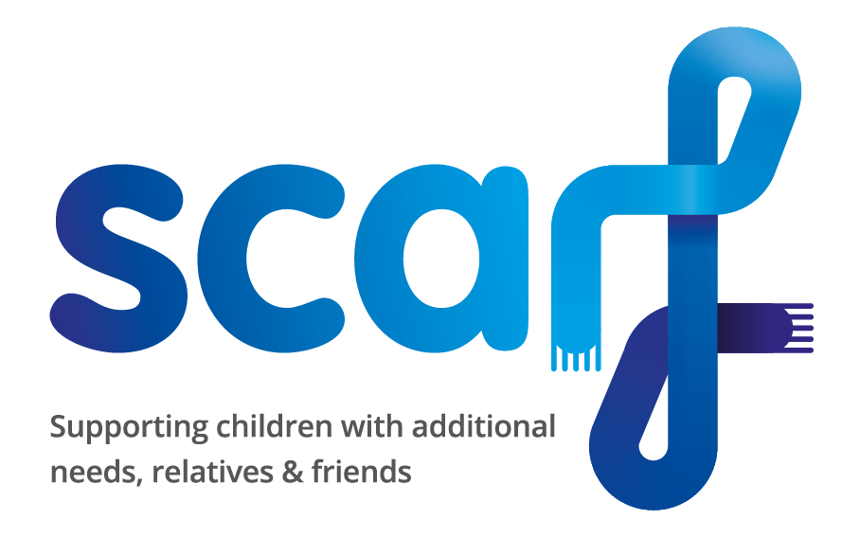
Scarf Asthma Medication Form
To be completed if your child/young person has asthma and needs to bring along an inhaler/reliever to a Scarf activity where parents/carers do not need to stay with them (eg. Multi Sports, Youth Club).
At the start of the session, the child/young person’s medication must be handed over to the club Supervisor and collected at the end. Medication must be labelled clearly with the child/young person’s name and details of the dose required, and in date. Please ensure there the inhaler is not empty.
Please let us know if there are any changes and this form needs updating. Also please give us an update if your child’s symptoms are worse (or better) than normal.
PLEASE GIVE US A COPY OF YOUR CHILD/YOUNG PERSON’S ASTHMA ACTION PLAN if they have one.
For further information please see Scarf’s Protocol on Administering Asthma Medication (Feb 2020).
Child/Young Person’s Name:

Date of Birth:

Address:

Parent/Carer’s Name:

Home Telephone Number: | Mobile Number:
Email address:

What asthma reliever medication is prescribed (must be prescribed by a GP or Consultant) and how do they take it, eg: does the child/young person use a spacer?

When should this medication be used, ie: what symptoms does your child/young person usually suffer with and how severe they can be? (eg. for shortness of breath, sudden tightness in the chest, wheeze or cough):

What dose is required? (ie: how many puffs and if symptoms are not relieved can the dose be repeated and when?)

Does your child/young person tell you when he/she needs this medication?

YES/NO
Does your child/young person need help taking his/her asthma medication (please describe help needed)?

YES/NO
What are the triggers (things that make their asthma worse)? Eg. pollen, stress, exercise, weather, cold/flu, air pollution, allergies, etc.

What signs can indicate if your child is having an asthma attack?

Does your child take any other asthma medications? (please name the medication and the dosage):

Signed: |  | Date:
Please print name here:

