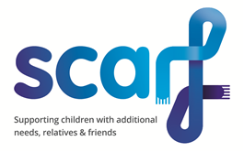
Gift Aid Declaration Form 2021
Supporting special children and their relatives and friends.

Boost your donation by 25p of Gift Aid for every £1 you donate
Gift Aid is reclaimed by Scarf from the tax you pay for the current tax year. Your address is needed to identify you as a current UK taxpayer.

In order to Gift Aid your donation you must tick the box below:

I want to Gift Aid my donation of £___________________ and any donations I make in the future or have made in the past 4 years to Scarf, Registered Charity No: 1015081

I am a UK taxpayer and understand that if I pay less Income Tax and/or Capital Tax than the amount of Gift Aid claimed on all my donations in the tax year it is my responsibility to pay any difference.

My Details.

Title __________ First name or initial (s) _______________________________

Surname ___________________________________________________________

Full Home address ___________________________________________________________________
___________________________________________________________________
___________________________________________________________________

Post Code _____________________________________ Date ______________

Please notify Scarf if you:

- Want to cancel this declaration
- Change your name or home address
- No longer pay sufficient tax on your income and/or capital gains.

If you pay Income Tax at the higher or additional rate and want to receive the additional tax relief due to you, you must include all your Gift Aid donations on your self-Assessment tax return or ask HM Revenue and Customs to adjust your tax code.

